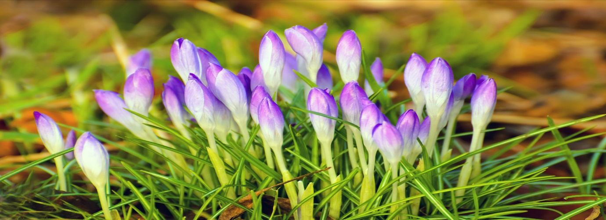

Time to get walking again!

At this time of year we start to think about the mud drying up and getting out to walk in the beautiful English Countryside again, but where to find new and interesting walks?
Walking in Warwickshire https://www.walkinginengland.co.uk/warwickshire has hundreds of walks to download and print, free, it also has books of walks, details of all the walking groups in the county and much more. Whether you want to walk on your own or with a group all the information is there in one place.
John Harris (the custodian of the website) said ‘There is so much walking information on the web but it is difficult to find. Walking in Warwickshire (part of the Walking in England website) has brought it together in one place so whether you are walking from home, or away on holiday, you will be able to find a walk suitable for you’.
With walks from half a mile to twelve miles plus long, and a note of suitability for pushchairs and wheelchairs, everyone can find a walk to enjoy.
So home or away, check out the websites and get walking!
John Harris
www.walkinginengland.co.uk
john@walkinginengland.co.uk

